User Manual for Autonomous Lawnmower Simulation

Introduction
- This program serves to simulate the operation of an autonomous lawnmower and works as a proof-of-concept, should production begin on a physical autonomous lawnmower, for guiding that machine using an adaptation of this code.
- Key functionality: autonomously mowing a lawn while avoiding obstacles, following a mosaic-based spiral mowing pattern.

Getting Started
- Installation and Launching the Program
  - This program has been packaged for easy use on windows computers. If you are using a windows computer, simply launch the included executable file by double-clicking it in your file explorer.
  - If you’re on a Mac or Linux-based computer, you can still run the program, but will need to do some setup.
    - First, open a new “Terminal” window. On Mac, this can be accomplished by holding the command key and pressing Space
    - in your terminal window, change to the folder where the simulation is by writing cd and then the file path to the folder e.g. cd path/to/simulation and then press enter/return
    - Install the simulation by writing pip install -r requirements.txt and hitting enter/return
    - Once installation finishes, launch the simulation by typing python3 main.py and hitting enter. Depending on your computer, you may instead need to use python main.py.

- Main Simulation Screen Overview
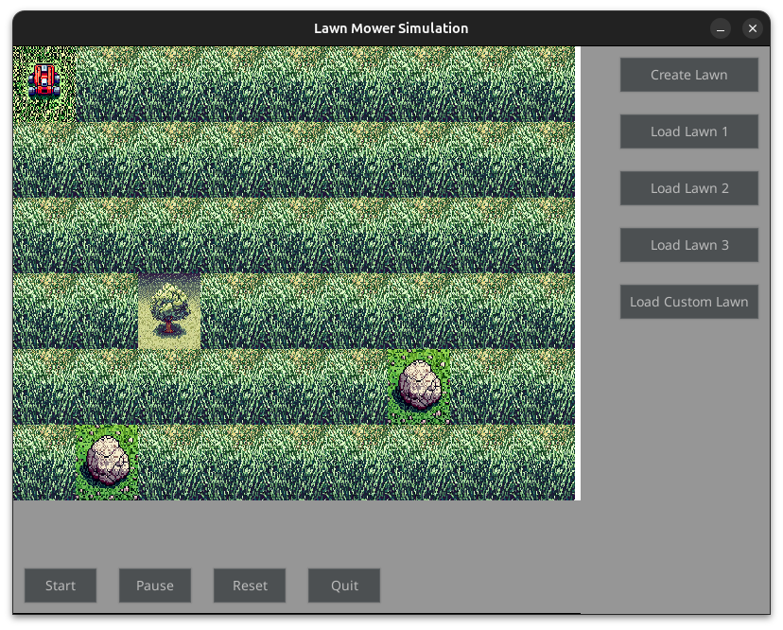
  - Shown above is the main screen of the simulation
  - Main screen button functions:
    - Start: Launch the mower. This single button is all you need to demo the program.
    - Pause: Pause mower operations in place.
    - Reset: Reset the screen to its original state.
    - Quit: Exit the simulation.
    - Create Lawn: Access the custom lawn editor (described below).
    - Load Lawn X: Load a predefined or saved custom lawn.

Custom Lawn Editor
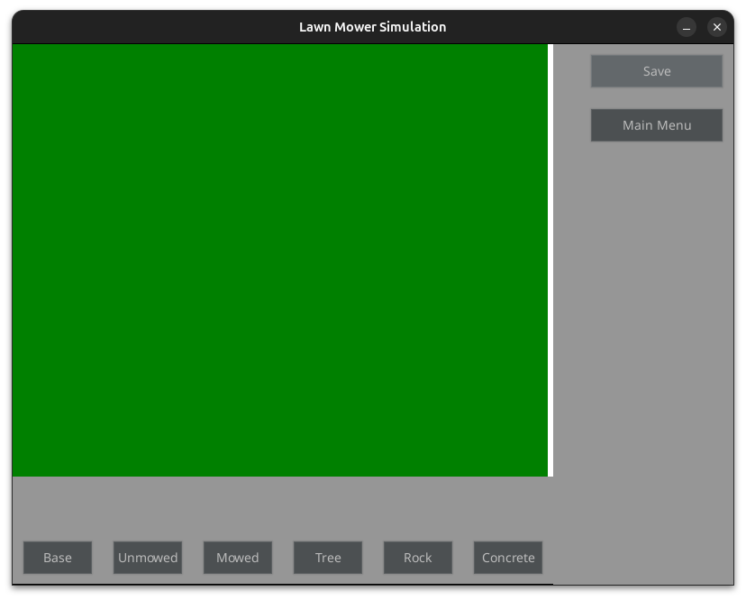
- Overview
  - Purpose of the editor: to allow users to create custom lawns by setting tiles.
- Tile Types and Functions
  - Base (Dock): Starting and ending point for the mower.
  - Unmowed: Grass awaiting mowing.
  - Mowed: Grass already mowed.
  - Tree, Rock, Concrete: Obstacles the mower avoids.
- Editor Controls
  - To modify one of the tiles on the screen, first click the type that you wish to convert the tile to and then click that tile. You may click as many tiles as you want and only need to click one of the “type” buttons when switching to laying some other type of tile.
- Button Functions
  - Save: Save the customized lawn for use in the simulation screen.
  - Main Menu: Return to the main simulation screen.

Tips for Effective Use
- To demonstrate the capabilities of the mower program, its best to include at least a few obstacles in any lawn being used for display purposes
- Stakeholders will likely find it a more compelling demonstration if you allow them to approximate their own yard and then testing there, but be aware that some lawns cannot be handled by one mower e.g. if a lawn has a row of obstacles going down the middle

Troubleshooting
- We are confident in the simulation that we’ve put together, but if you run into difficulties installing or running the simulation, please don’t hesitate to reach out. This with any programming familiarity will also find the internet an abundant resource for any issues that arise, thanks to this simulation being written in the popular coding language Python.

Feedback and Support
- teambest@automower.com
- Find us on the company Slack in the #team-best channel! This is the channel by which we are most responsive
- For reworking features within the simulation, please submit an engineering ticket. We’ll be in touch to establish reasonable timeline expectations shortly thereafter.

Finally, thank you! We’re excited for the opportunities ahead and realize what a company-wide effort will be required to dominate in this opening market niche. If you’re reading this manual, you’re part of that effort!

